**Cisco Router:**

* Router is a hardware device work on Layer 3 or Network Layer of OSI Model.
* Router connects minimum of two networks generally find at the gateway.
* Router is used to interconnect two more different LANs with each other.
* Router is used to connect a LAN with WAN; Router is used to control broadcast.
* Router divide broadcast domains create routing table to store network information.
* Router is a device which select best path on the basis of routing protocol.
* Cisco Switches create a network and Cisco Routers connect different networks.
* Router uses a combination of hardware and software to "route" data.
* Routers segment large networks into logical segments called subnets.
* Router is networking device that forwards data packets between computer networks.
* Router is a layer 3 device used to forward packet from one network to another.
* Router perform various functions such as Static Routing and Dynamic Routing.
* Router also perform other various functions such as NAT (Network Address Translation), ACL (Access Control List), Inter VLAN Routing

**Memory Components:**

* Ram
* Rom
* VRAM
* NVRAM
* Flash Memory

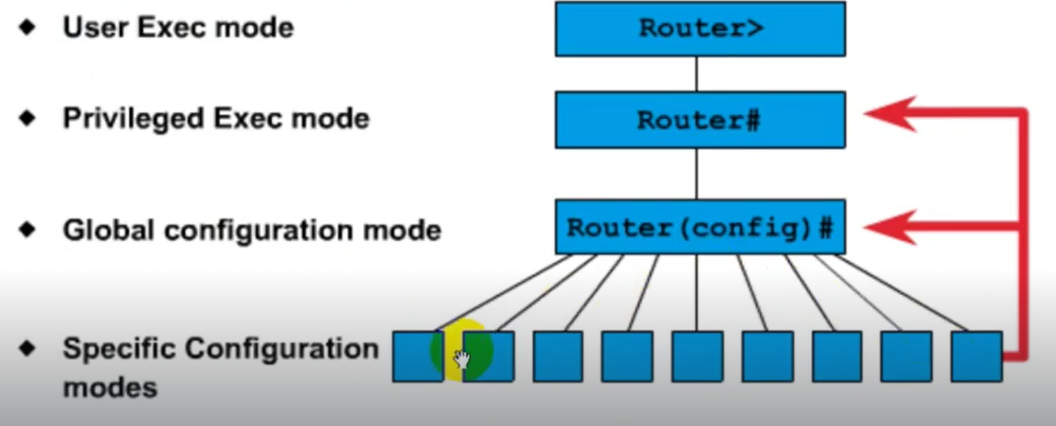**Configuration Modes:**

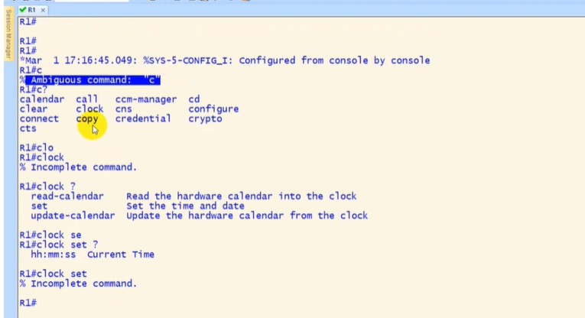**Common Error In Router Console:**

**Cisco Operating System:**

1. **IOS operating system:**

* Cisco IOS (Originally Internetwork Operating System) is a family of software.
* IOS is an Operating System used on Cisco devices, such as routers and switches.
* Multitasking OS that implements and controls logic and functions of a Cisco device.
* Cisco IOS runs as a single image and all processes share the same memory space.
* To configure a Cisco device running IOS, the Command-Line Interface (CLI) is used.
* CLI comes with predefined number of commands to configure routing & switching.
* The CLI is usually accessed from local or remote Computer running Telnet or SSH.
* The IOS is usually stored as a system image within a router or switch flash memory.

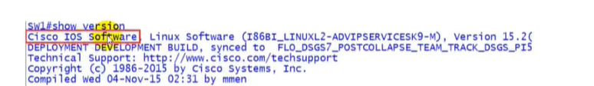Not all Cisco products routers or switches run IOS (Internetwork Operating System).

1. **Cisco IOS-XE:**

* Cisco IOS XE is & flexible OS optimized for era Of networks.
* iOS XE use Linux operating system where IOS runs as a separate process on Linux.
* As the single OS for enterprise wired and wireless access. aggregation, core. and WAN.
* Cisco IOS-XE is advanced version of IOS and both IOS and IOS-XE share a lot Of same codes,
* Cisco IOS-XE is the -new- Linux based OS Cisco introduced in 2008 with the ASR Routers.
* Cisco IOS-XE comes with many enhancement & features compared to Older verse
* Cisco IOS-XE support symmetric separate
* It provides empowered software architectural strategy, while maintaining all the o" benefits.
* Supports multiple CPU Cores. control data plane separation, & abstraction
* Cisco IOS XE looks like and is managed the same way as Cisco iOS Software.

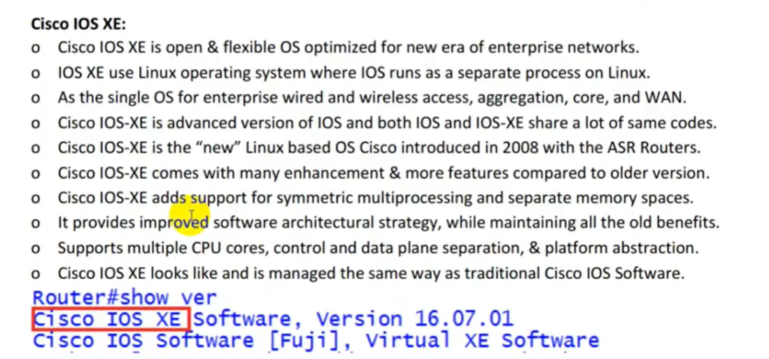

1. **Cisco IOS-XR:**

* Cisco IOS XR OS runs on a number of Cisco's large, service-provider focused platforms.
* IOS XR is Real Time Internetwork Operating System designed for high-end carrier routing.
* XR is mainly for service provider networks but it can also be use in enterprise network.
* Found on Cisco service provider routers such as XR 12000 Series router runs Cisco IOS-XR.
* NX-OS is built on a Linux kernel, IOS-XR is built on the QNX Neutrino Microkernel.
* QNX is similar to UNIX Operating System and is now owned by BlackBerry Company.
* NX-OS is the ability to have single instance of operating system controlling multiple chassis.
* used on high-end Network carrier-grade routers such as the CRS series and ASR9000 series.

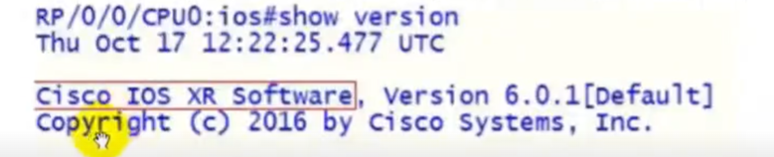

TPYES OF ROUTERS:

1. **Modular Router:**

* Modular router means that can plug different interface modules into the router.
* Can add additional any Serial port as well as Ethernet port in to the Router.
* Modular interface series router has choice to install the ports according to requirement.
* In modular interface series router, the interface nomenclature is type slot_#/port_#.
* Example in 1841 router two Ethernet ports are installed, named F 0/0 & FastEthernet 0/1.
* Modular Switches giving you the flexibility if your network needs change.
* SR routers are a particular line of Cisco routers, namely, 800, 1800, 2800, and 3800 series.

1. **Fixed/Non-Modular Routers:**

* Non-modular router is low-end router and have fixed interfaces or Cards.
* These routers are routers with fixed number of ports & are typically not expandable.
* we cannot add additional serial port as well as Ethernet port in this Router i.e. 2500 Series.
* In fixed or non-modular interface series router, all slots & ports are integrated with device.
* In fixed router, interface numbers always start with O goes way up within specific interface.
* In fixed interface series router, the interface nomenclature is type port_#.
* Suppose, fixed interfåce router has two Ethernet then they named Ethernet O, Ethernet 1.
* For example, 2503 series router has two fixed serial interfaces; so serial O and serial 1.

1. **ISR (Integrated Service Router)**

* ISR generally used as internet edge for customers with small/medium networks.
* integrated services architecture that specifies elements to guarantee QoS (Quality of services) on networks.
* ISR routers are used to allow video and sound to reach the receiver without interruption.
* ISR include 800, 1900 Series ISR, 2900 Series ISR, 3900 Series ISR, 4000 Series ISR, etc.

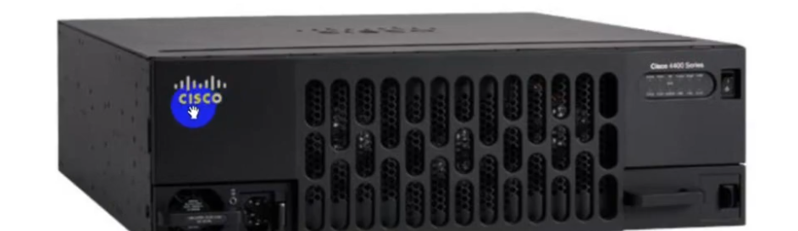

1. **ASR (Aggregation Services Routers) Router:**

* ASR generally used as internet edge for enterprise networks and service providers.
* ASR consist Of 900 Series ASR, 1000 Series ASR, 5000 Series ASR, 9000 Series ASR, etc.
* Cisco's ASR Router series are best suited for enterprises & service providers.

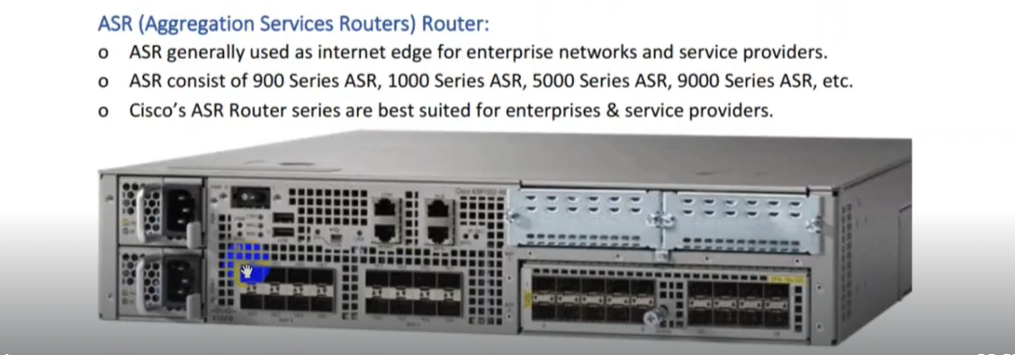

1. **CRS (Carrier Routing System) Router:**

* Cisco CRS typically used in (IP/MPLS) core networks and for high-speed peering location.
* Cisco CRS is modular and distributed core router developed by Cisco Systems.
* CRS enables service providers to deliver data, voice, and video services over a scalable IP.

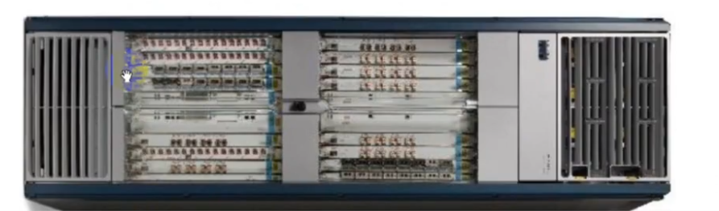

**Configuration:**

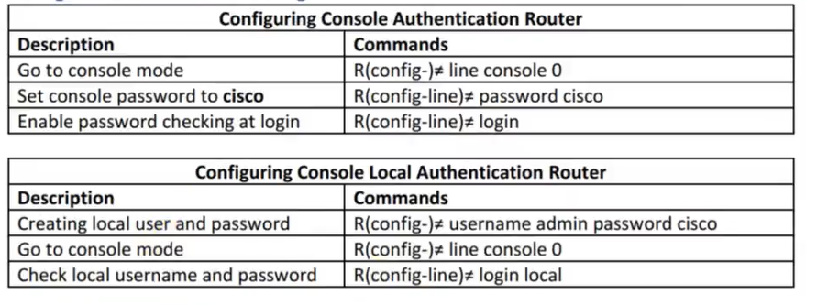

**Routed Protocol:**

* Routed protocols are the actual data that is transferred from router to router.
* Examples of routed are Internet Protocol (IP) such as IPV4 and IPV6.
* Routed Protocol is used to send user data from one network to another network
* Routed Protocol carries user traffic such as e-mails. file transfers, web traffic etc.
* Used between routers to direct user traffic. it is also called network protocols.
* That are signs at intersections that point to nearby cities. giving mileage to each.

**Routing Protocol:**

* Routing protocols are used by routers to exchange information about known networks.
* Routers will initially only know the existence of directly connected or attached networks.­­­­­
* With the use of routing protocols routers communicate with & learn from other routers.
* Routing protocols are used to distribute routing information across routers on a network.
* Routing protocol is Google Maps: It tells you the best way to get where you want to go.



**Routing Classification:**

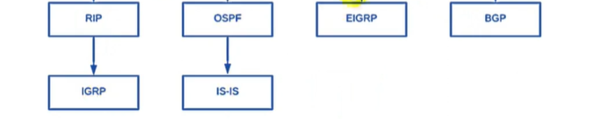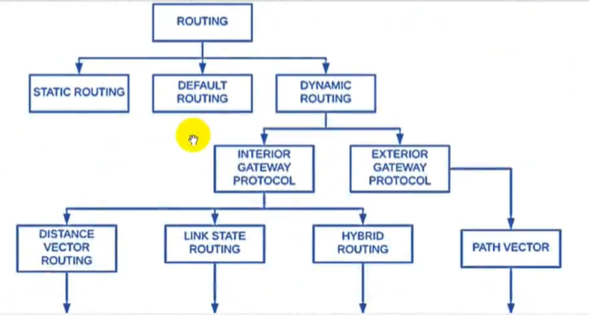

**Static Routing:**

* Static Routing administrator manually inputs all routing table information.
* A static route is a route that is created manually by a network administrator.
* Router's routing table entries are populated manually by network administrator.
* Static route tells the network devices about exact location for the routes.
* Static routes are typically and can only be used in the smaller networks.
* Configure static routes between routers to allow data transfer between routers.
* The command used in static is IP route network, mask address/interface (distance).
* Example: IP route 2.0.0.1 255.0.0.0 1.0.0.2. Here, 2.0.0.0 is destination network.
* In example, 255.0.0.0 is subnet mask and 1.0.0.2 is the default gateway ip address.
* Major advantages of static routing are reduced routing protocol router overhead.
* Another advantage of static routing it reduced routing protocol network traffic.
* Disadvantages of static routing are network changes require manual reconfiguration.
* Easy to Configure, High Secure, Use Low Resources, Bandwidth & Use in Small Network.
* Static Routing doesn't not require Advanced Knowledge to configure them.
* Static Routing not able to support VLSM It is only support class full Network.
* Not Scalable also Administrator should know the destination IP-address to configure.
* When changes occur in the network Configured by the administrator manually only.

**Default Routing:**

* A Default Route also known as the gateway of last resort is a special type of static route.
* This method where all routers are configured to send all packets towards single router.
* Default Route is Network Route used by router when there is no other known route exists.
* All the IP datagrams with unknown destination address are sent to the default route.

**Dynamic Routing:**

* Dynamic routing protocols can dynamically respond to changes in the network.
* Routing protocol is configured on each router & router learn about both each other.
* Dynamic routing table is created, maintained and updates by the routing protocol.
* Examples of routing protocols includes RIPVI, RIPv2, ISIS, EIGRP, and OSPF and BGP.
* Dynamic routing protocols share routing updates with neighbours and find best path.
* Dynamically choose a different route if a link goes also Updates are dynamically.
* Also, Dynamic Protocols has the ability to load balance between multiple links.
* Dynamic Routing protocols put additional load on the Router CPU and RAM.
* The choice of the best route is on the hands of the dynamic routing protocol.

**Exterior Gateway Protocol (EGP):**

* A routing protocol operating between different Autonomous System (AS).
* Exterior Gateway Protocol is usually used on Internet, between different AS.
* EGP is used to exchange routing info between different autonomous systems.
* Border Gateway Protocol (BGP) is the only EGP used nowadays.
* Commonly used for ISP to exchange routing with other ISPs or Upstream.
* EGP is commonly used between hosts on Internet to exchange routing table info.

**Path Vector Protocol:**

* Path Vector Protocol relies on number of autonomous systems it must go through.
* It chooses path with least number of autonomous systems to reach the destination.
* BGP is a Path Vector Protocol, it does not rely on the bandwidth of the links like OSPF.
* BGP does not rely on hop count like RIPv1, RIPv2 or a group of parameters like EIGRP.

**IGP (Interior Gateway Protocol):**

* Usually routers running IGP are under the same administration of a company.
* IGPs are used to exchange routing information within same Autonomous system.
* IGP are basically routing protocols used internally into company to exchange info.
* Commonly used in LAN/Private networks where private IP addresses are used.
* Corporation or individual, or ISP. Example RIPVI, RIPV2, OSPF, EIGRP, and ISIS.

**Vector Distance:**

* Distance vector routing protocol uses distance (metric value) and direction (vector).
* Distance Vector use distance and vector to find the best path to destination network.
* In Distance Vector routing router receives routing update from neighbouring router.
* In distance vector neighbouring routers receive updates from their neighbouring routers.
* In this way, distance vector routing protocol work until the destination network.
* In Distance Vector routing, every router in the way of destination network called hop.
* Each time a packet goes through a router, it adds one in hop count value or number.
* Route with least hop count value chosen as best path & will be placed in routing table.
* RIP version 1 and RIP version 2 is the example of distance vector routing protocol.
* These protocol shares entire routing table to the directly connected neighbours.
* Distance Vector Routing Protocols are slow and have a chances for loops.
* Distance means (How far Away) and Vector means (Which Direction).

**Link State:**

* As compare to distance routing Link State Routing Protocols operate differently.
* Routers send information about the state of their links to the entire network or area.
* In this way, in Link State Routing each router understands the entire network topology.
* Run algorithm every time network change is announced to recalculate best routes.
* As compare to other Link State Routing Protocols much more processor intensive.
* Link State Routing Protocols only send triggered updates not periodic updates.
* Link State Protocols maintain three separate tables Neighbour, Topology & Routing Table.

**Hybrid Routing Protocol:**

* Hybrid Routing protocol has advantages of both Distance Vector & Link State Routing.
* Hybrid Routing protocols merges both distance & link state protocol into new protocol.
* Typically, the hybrid routing protocols are based on a Distance Vector protocol.
* But contain many of the features and advantages of Link State Routing protocols.
* Example of Hybrid Protocol is EIGRP (Enhanced Interior Gateway Routing Protocol).

**Floating Static Routes:**

* If want to use a static route as a backup route, we have to change its AD.
* To make static route as a backup route, this is called a floating static route.
* Floating static routes are used for redundancy in-case an interface fails or down.
* Floating static route is route that has higher AD then current route in routing table.
* AD is configured on static so that static route is less desirable than dynamic route.
* In this manner, the static route is not used when the dynamic route is available.

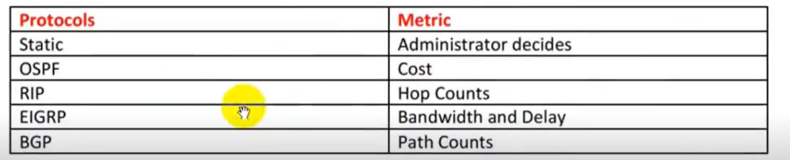

**Autonomous System:**

* Autonomous system is one network or sets of networks under a single administrative.
* AS is a set of routers and devices, or even a set of networks, controlled by a single entity.
* Autonomous System (AS) example such as Pepsi, Apple, Microsoft, Facebook etc.

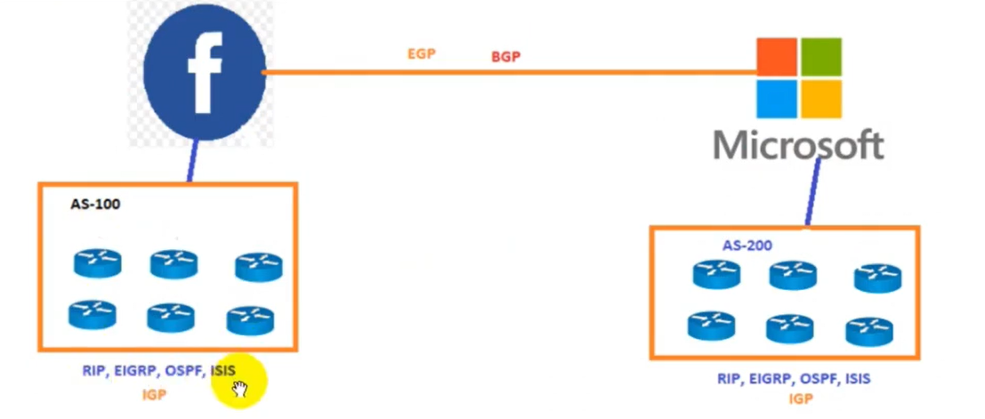

**Administrative Distance:**

* Administrative distance is the feature that routers use to select best path.
* Administrative Distance (AD) defines the reliability of a routing protocol.
* The administrative Distance (AD) number is start from O and end on 255.
* AD has only local significance and is not advertised in the routing updates.
* The smaller the administrative distance value, the more reliable the protocol.
* Router is running multiple routing protocols; AD is to determine trustable protocol.
* Routing Protocol with lowest Administrative Distance (AD) wins put in routing table.

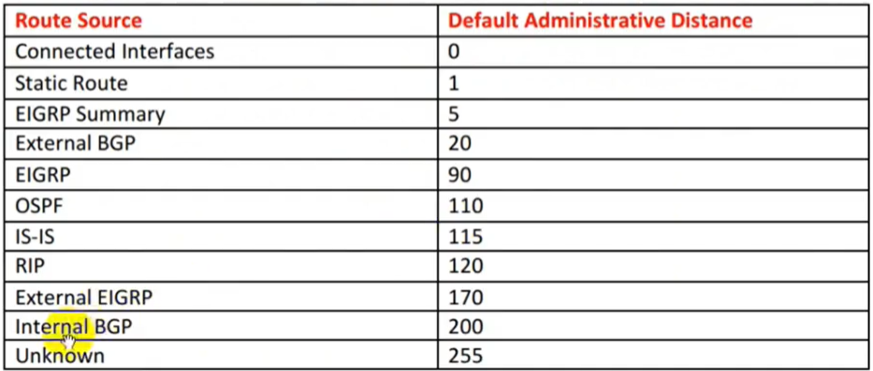

**ARP (Address Resolution Protocol):**

* This protocol is used to map/match the ip of a device to its Mac Address
* This protocol coverts 32 bit number of a device to 48 bit number
* ARP translate Internet Protocol address to Media Access Control address.
* Address Resolution Protocol translate Layer 3 address to Layer 2 address.
* Network Layer protocol used to convert an IP address into a physical address.
* ARP is used to convert the IP address into its physical correspondence called MAC.
* Address Resolution Protocol request broadcast & ARP response is a Unicast.
* The protocol that determines MAC address from the IP address is called ARP.
* Address Resolution Protocol (ARP) has always been a Layer 2 protocol not Layer 3.
* Address Resolution Protocol default ARP aging time is 4 hours or equal 240 mints.
* By default, entry will be removed from ARP table if it wasn't used in 240 minutes.
* Just keep in mind the Cisco Switch hold the CAM table entries only for 5 minutes.
* If see "O" that means having traffic in that interface just less than a minute ago.
* Permanent ARP entry does not have any timer associated with it is show as
* Permanent ARP entry does not have any timer associated with it is show as ‘–‘
* Address Resolution Protocol only works between devices in the same IP Subnet.

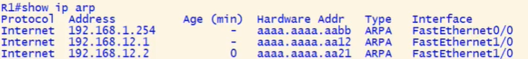

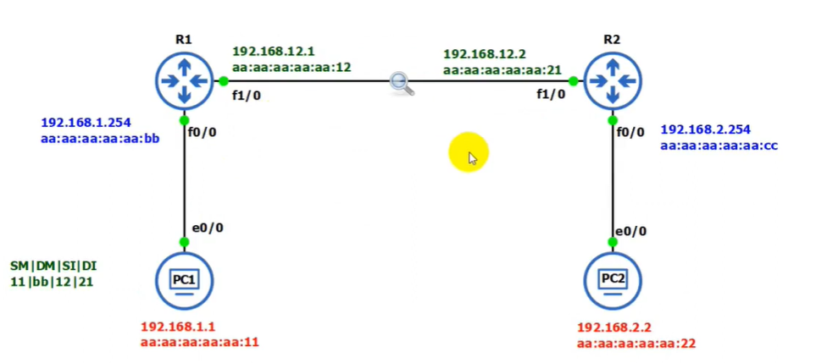

* One Packet will be lost when ping PC1 to PC2 because this is lost by arp to find which device has the pinged ip and it find gain its MAC Address for further communications.

|  |  |  |  |
| --- | --- | --- | --- |
| Source IP | Dest. IP | Source MAC | Dest. MAC |
| 192.168.1.1 | 192.168.2.2 | aa:aa:aa:aa:aa:11 | aa:aa:aa:aa:aa:bb |
| 192.168.1.1 | 192.168.2.2 | aa:aa:aa:aa:aa:12 | aa:aa:aa:aa:aa:21 |
| 192.168.1.1 | 192.168.2.2 | aa:aa:aa:aa:aa:cc | aa:aa:aa:aa:aa:22 |

Protocol: The protocol type, almost always Internet.

Address — The IP address associated with the MAC address, The IP address of RI.

Age — By default, entry remove from ARP table if it wasn't used in 240 minutes.

O in this column means that the entry was last used O minutes ago.

Each time an entry is use$7 the age will be reset back to zero.

Hardware — The MAC address of the host with the corresponding IP address.

Type — The type of hardware address. For Ethernet, this value will always be ARPA.

Interface — The interface on RI on which the corresponding host is connected.

**Gratuitous ARP:**

* Gratuitous Address Resolution Protocol is used in advance network scenarios.
* It is something performed by computer or network devices while booting up.
* When device booted up first time, it automatically broadcast its MAC address.
* After Gratuitous ARP MAC address of the computer is known to every device.
* And allow DHCP servers to know where to send the IP address if requested.
* Gratuitous ARP could mean both Gratuitous ARP request & Gratuitous ARP reply.
* Gratuitous ARP is ARP-Reply that was not prompted by an ARP-Request.
* Hosts on network send out a Gratuitous ARP when they are initializing their IP stack.
* GARP is an ARP request for their own IP address & is used to check for duplicate IP.
* Gratuitous Address Resolution Protocol is useful to detect IP conflict.
* If there is a duplicate address, then the stack does not complete initialization.
* GARP is also used to update ARP mapping table & Switch port MAC address table.



Verify IPv4 Address

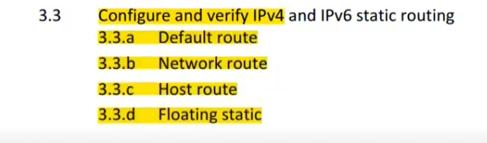

**Configure & Verify Static Routing:**

* When routers learn from a Network administrator, it is called a static routing.
* In Static Routing administrator manually inputs all the routing table information.
* Static route tells network devices about exact location & only work in small network.
* In static routing, we must add all network locations manually or statically in router.
* If any change occurs in the network, admin is responsible to update it in all routers.
* Keep in mind, that a static route will have a default administrative distance (AD) of 1.
* To keep route all time in Routing table, permanent keyword to end of route statement.
* This keyword will keep the route in the table even if the router interface goes down.

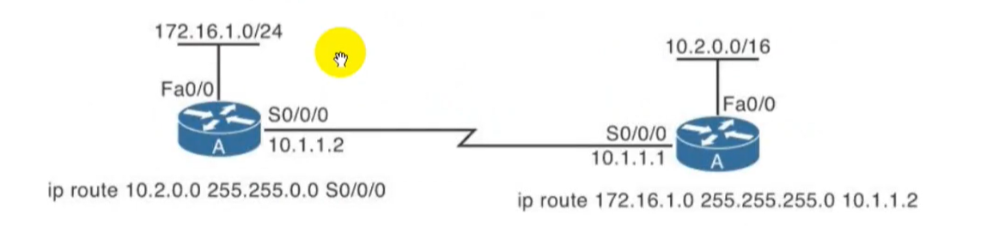

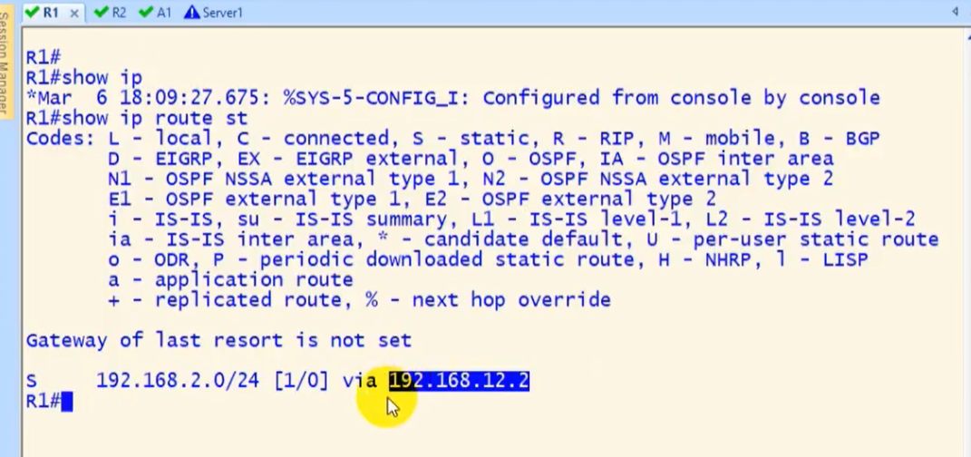





* 192.168.2.0 is the 2nd network ip “0” shows it can be .1, .2, .3 etc. 255.255.255.0 is subnet mask. 192.168.12.2/e0/1(R1) this show r1 will send packets to to its interface e0/1

**Default Route:**

* A Default Route also known as the gateway of last resort is a special type of static route.
* Default route is route that router uses to forward an incoming packet when no other route.
* This is method where all routers are configured to send all packets towards a single router.
* Where static route specifics a path, a router should use to reach a specific destination.
* Default route specifies a path router should use if it doesn't know how to reach destination.
* Default Route is Network Route used by a router when there is no other known route exists.
* Default Route is used by router when there is no other route for IP destination address.
* All the Internet Protocol with unknown destination address are sent to the default route.
* If no default route is set router will discard all packets with destination addresses not found.
* This is very useful method for small networks or for networks with single entry & exit point.
* All zero (0.0.0.0) in network portion and subnet mask represent all networks and all hosts.

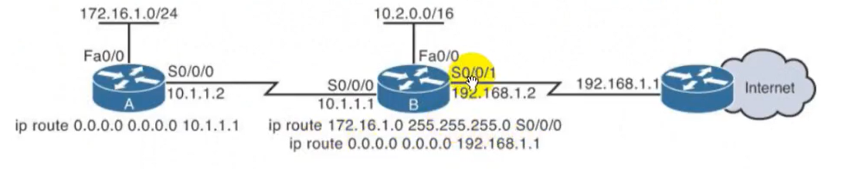

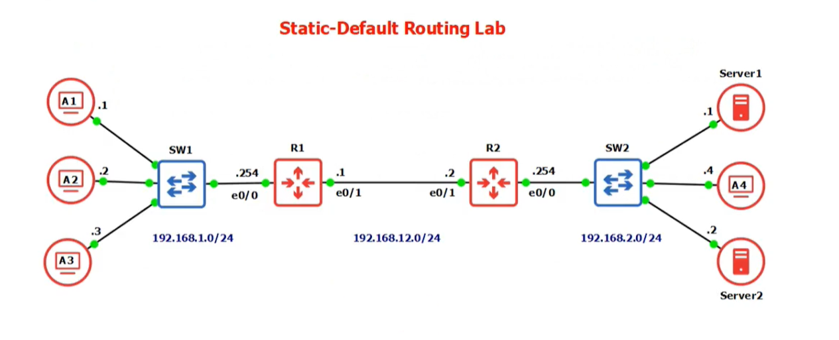



**Network Route:**

* Network Route used by a router when there is no other known route exists.
* All the IP with unknown destination address are sent to the default route.
* Network Route is route for a classful network most entries are network routes.

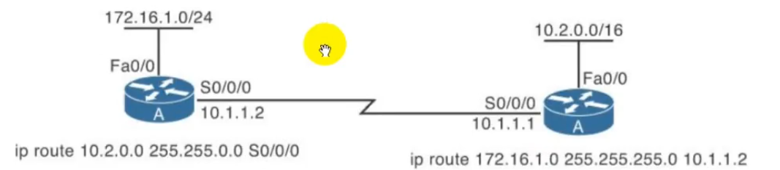

**Host Route:**

* It is where destination address is a specific device IP with a subnet mask of /32 for IPv4.
* It is where destination address ins specific device IP with a subnet mask /128 for IPv6.
* Also, installed Automatically when an IP address is configured on the router interface.
* Hosts attached directly connected to routers are host routes & route for certain hosts.
* They are advertised with a mask all I's indicating a single destination is the Host Route.
* An engineer might use host routes to direct packets sent to one host over one path.

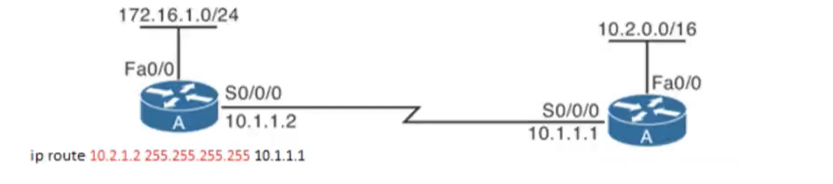

**Floating Static Routes:**

* Floating static route is route that has higher AD then the current route in a routing table.
* The Floating Static Route are very useful, when providing a backup to a primary link.
* Static Floating route is static route like any other but with added AD in the configuration.
* Static floating route is the same as normal static route except that this kind of static route.
* That has administrative distance configured to some value higher than I of default value.
* As we know, that a static route will have administrative distance (AD) of 1 by default.
* Router ignores static route during times when the better routing protocol route is known.
* It is used for a Backup Static Route, a second route is defined with a high Preference AD.
* If the first Primary link fails, then this floating static route is used as a Backup link to use.

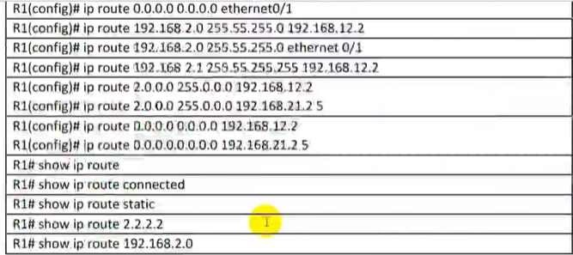

**Default Route**: Ip route 0.0.0.0 0.0.0.0 192.168.12.2(next hop ip address)

R2 have same configuration with hop address with existed one.

**Nework Route**: Ip route 192.168.2.0 255.255.255.0 192.168.12.2(next hop ip address)

**Host Route:** Ip route 192.168.2.1 255.255.255.255 192.168.12.2(next hop ip address)

**Float Route**: ip route 0.0.0.0 0.0.0.0 192.168.12.2

ip route 0 0.0 0.0 00.0 192.168.21.2 5(AD)

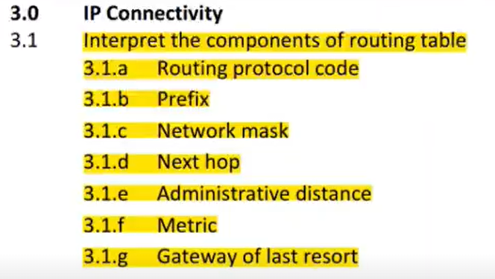

**Routing Prefix & Network Mask:**

A subnetwork or subnet is a logical subdivision of an IP network. Expressed in CIDR notation

written as the first address of a network, followed by a slash character (/), and ending with the

bit-length of the prefix. Example like 172.16.4.0/28. It is Destination Network, Identifies the

address of the remote network and /28 is Network Mask.

**Next Hop:**

Identifies the IPv4 address of the next router to forward the packet to. Example like

209.165.200.226 in above given table.

**Routing Protocol Code:**

It's called Route Source Identifies how the route was learned. Common codes include O (OSPF),

D (EIGRP), R (RIP), S* (Static Default), S (Static) and B (BGP). Example like R in above given table.

**Administrative Distance:**

* Administrative distance is the feature that routers use to select best path.
* Administrative Distance (AD) defines the reliability of a routing protocol.
* The administrative Distance (AD) number is start from O and end on 255.
* AD has only local significance and is not advertised in the routing updates.
* The smaller the administrative distance value, the more reliable the protocol.
* Router is running multiple routing protocols; AD is to determine trustable protocol.
* Routing Protocol with lowest Administrative Distance (AD) wins put in routing table.



**Metric:**

Routers use various metrics and calculations to determine the best route for a packet to reach

its final network destination. Each routing protocol uses its own algorithm with varying weights

to determine the best possible path. Identifies the value assigned to reach the remote network.

Lower values indicate preferred router. Example like 2 hops in above given table.

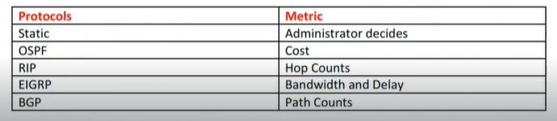

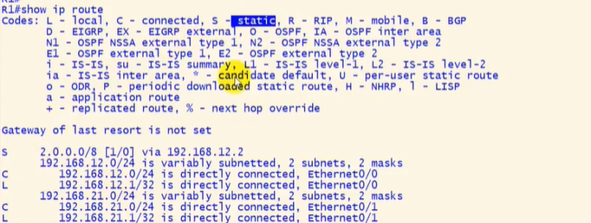

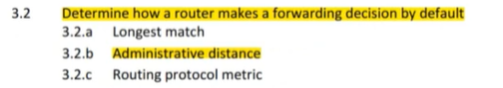

**Longest Match:**

Cisco routers use the longest prefix match rule when determining which of the routes placed

into the routing table should be used to forward traffic to a destination network or node.

Longer, or more specific routing table entries are preferred over less specific entries, such as

summary addresses, when determining which entry to use to route traffic to the intended

destination network or node. The longest prefix or most specific route will be used to route

traffic to the destination network or node regardless of the administrative distance of the route

source, or even the routing protocol metric assigned to the prefix is multiple overlapping

prefixes are learned via the same routing protocol.

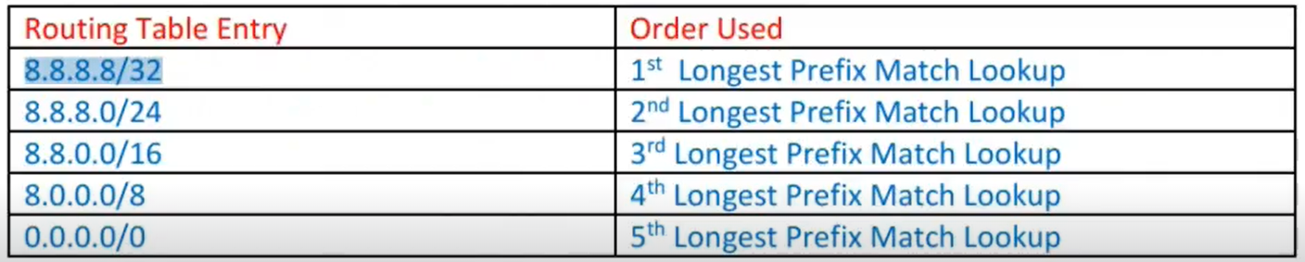

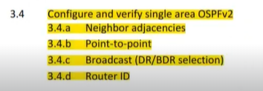

**OSPF (Open Shortest Path First) Protocol:**

* OSPF is term which stands for Open Shortest Path First.
* Link State protocol sends update based in state of the link.
* When a link comes up and goes down it sends the updates.
* OSPF protocols is a dynamic open standard Routing Protocol.
* OSPF protocols is the Link-State dynamic routing protocol.
* OSPF protocols uses the Shortest Path First (SPF) algorithm.
* OSPF protocols uses IP protocol type 89 (not TCP or UDP).
* OSPF External and Internal Administrative Distance is 110.
* OSPF is a classless Routing protocol and OSPF metric is Cost.
* OSPF use multicast address 224.0.0.5 to send the hello packet.
* OSPF use multicast address 224.0.0.6 for all designated routers.
* OSPF default Hello time is 10 seconds and dead time is 40 seconds.
* OSPF protocols supports both the VLSM (Variable Length Subnet Masking) and route summarization.
* OSPF use wildcard mask, which is the reciprocal of subnet mask.
* OSPF protocols supports both MD5 and clear text authentication.
* OSPF protocols supports the summarization at ABRs router only.
* OSPF are requires more memory and CPU processing to run.
* OSPF work on area, Area O is the backbone of OSPF technology.
* OSPF have Neighbour table, Topology table and Routing table.
* OSPF packets are only sends to the neighbour of own Area.
* OSPF protocols supports both IPv4 and IPv6 routed protocols.
* OSPF load balancing with equal cost routes for same destination.
* OSPF dynamic routing protocols supports unlimited hop counts.
* OSPF protocols supports trigger updates for fast convergence.
* OSPF sends update with a sequence number of Ox80000001.
* The sequence number ends with Ox7FFFFFFF and start again.
* The sequence number will increment by one in every updates.
* OSPF protocol is more complex to setup and hard to troubleshoot.

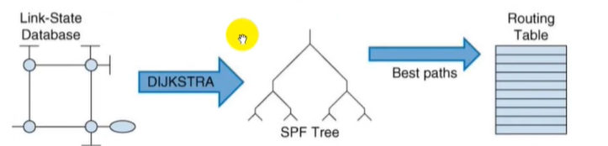

**OSPF Terminologies:**

**Area:**

* In Open Shortest Path First (OSPF) dynamic protocol Area is like a Subnetting.
* It allows separating the large internetwork into smaller networks known as areas.
* OSPF implements two levels hierarchy with areas: backbone and area off backbone.

**Backbone:**

* In Open Shortest Path First Protocol Backbone is central point of this implementation.
* Routers running in this area required to maintain complete database of entire network.
* All areas in Open Shortest Path First (OSPF) Protocol is needed to connect with this area.

**Area off Backbone:**

* In Open Shortest Path First (OSPF), Area off backbone is the extension of the backbone.
* Routes running in this area required to maintain specific database instead of complete.
* In Open Shortest Path First (OSPF), protocol It will speed-up the convergence time.

­­­

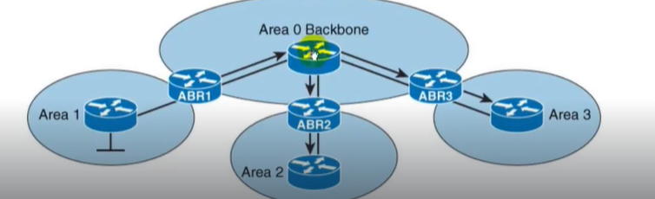

**Router ID:**

* Every Router in Open Shortest Path First network, needs the unique OSPF Router ID.
* The OSPF Router ID is used to provide & give a unique identity to the OSPF Router.
* There are different ways in Open Shortest Path First protocol which it can be identified.
* The highest IP address of the active Physical interface of the router becomes the Router ID.
* If a logical interface is configured, then highest IP address of logical interface becomes RID.
* If specify the Router-ID manually then it takes priority over all and become the Router-ID.

**Link:**

* Link is an interface running Open Shortest Path First (OSPF) routing protocol.
* When we add an interface in OSPF process, it will be considered as a link.

**State:**

* In Open Shortest Path First (OSPF), State is the information associated with an interface.
* A link or Interface contains several information such as IP address, up/down status, subnet.
* A link also has subnet mask, type of interface, type of network, bandwidth and delay etc.
* Open Shortest Path First (OSPF) dynamic protocols consider this information as the state.

**LSA:**

* Link State Advertisement (LSA) is data packet, it contains Link-State & routing information.
* Open Shortest Path First dynamic protocol uses it to share & learn network information.

**LSDB:**

* Every Open Shortest Path First (OSPF) router maintains a Link State Database (LSDB).
* Link State Database (LSDB) is collection of all Link State Advertisement received by router.
* Every LSA has unique sequence number, OSPF stores LSA in LADB with sequence number.

**Internal Router:**

* It is a router that has only OSPF neighbor relationships With routers in the same area.
* In Open Shortest Path First (OSPF) Internal Router has all of its interfaces in single area.

**Backbone Router:**

* The area O is known as backbone area & routers in area O are known as backbone routers.

**Designated Router (DR) and Backup Designated Router (BDR):**

* Designated Router is router interface elected among all routers on network segment.
* And Backup designated (BDR) is a backup for the Designated Router (DR) in OSPF.
* DRS are used for reducing network traffic by providing a source for routing updates.
* The Designated Router (DR) maintains a complete topology table of the network.
* The Designated Router (DR) sends the updates to the other routers via multicast.
* All routers in an area will form slave/master relationship with Designated Router (OR).

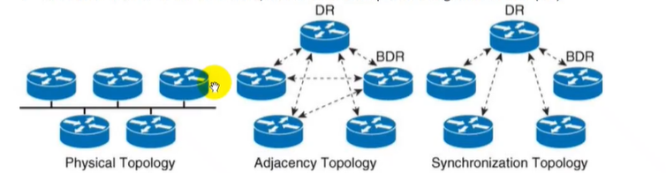

**Router Priority:**

* It is used to determine who will become Designated or Backup Designated Router.
* In Open Shortest Path First (OSPF) Dynamic Protocols The default priority is one (1).
* In Open Shortest Path First (OSPF) Router Priority, value range is between O to 255.
* The range of priority values that allow a router to be a candidate are I to through 255.
* A priority setting of (O) zero means that the router does not participate in the election.
* Changing the priority setting to zero (O) means router can never become the DR or BDR.

**Area Border Router (ABR);**

* ABR is router that connects one or more OSPF areas to the main backbone network.
* Area Border Router (ABR) is considered a member of all areas it is connected to.

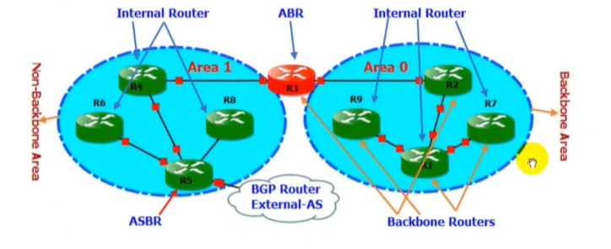

**OSPF Tables:**

Each OSPF router stores routing and topology information in three tables: Neighbor table,

Topology table and Routing Table.

**OSPF Routing Table:**

OSPF stores single best route for each destination in this table. Router uses this table to

forward the packet. There is a separate routing table for each routed protocol.

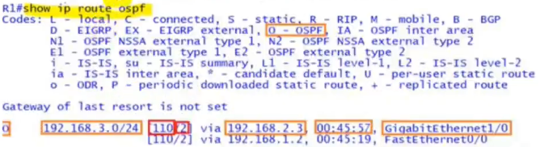

**OSPF Neighbour Table:**

Contain information about the neighbours; Neighbour table includes all neighbours that is directly

connected to router using OSPF, contains all discovered OSPF neighbours with whom routing

information will be interchanged.

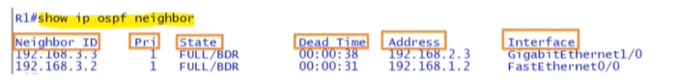

**OSPF Topology Table:**

Topology Table contains the entire road map of the network with all available OSPF routers and

calculated best and alternative paths. The OSPF database contains all LSAS that describe the

network topology.

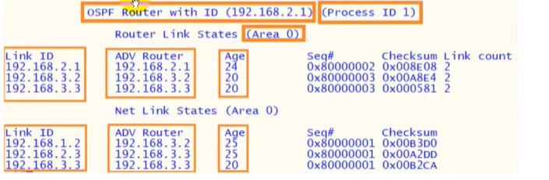

**OSPF RID (Router ID):**

* RID is a unique identifier of Router in Open Shortest Path First (OSPF) network.
* RID must be unique within the autonomous system in Open Shortest Path First.
* Through Router ID (RID) Routers identify each other in AS (Autonomous System).
* Router ID is 32-bit long number same as Internet Protocol version 4 (IPV4) address.
* IPv4 address is also 32 bit in length you can use IPv4 address as a RID (Router IO).
* Manual configuration => Loopback Interface => Active interface while selecting RID.
* If assigned Router ID (RID) manually, OSPF will not look in next two options to use.
* When multiple IP addresses are available, OSPF always pick highest IP address for RID.
* For network, stability always set RID by router-id command or using loopback interfaces.

**Routers Selection RID:**

An Open Shortest Path First (OSPF) Router looks in three places for RID (Router It)):

* In Open Shortest Path First (OSPF) Router look Manual configuration of router ID.
* In Open Shortest Path First Router look Highest IP address on loopback interface.
* In Open Shortest Path First Router look Highest IP address on physical interface.

**WireShark Hello Packet:**

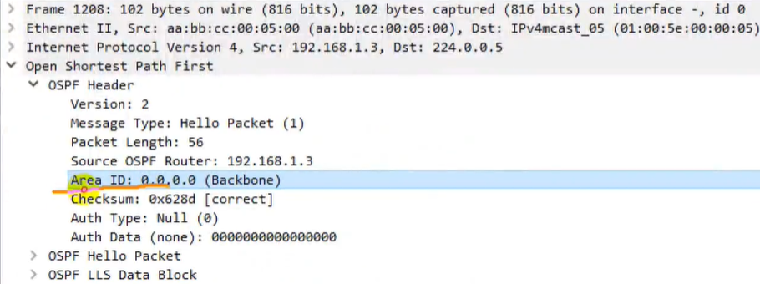

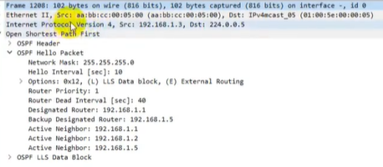

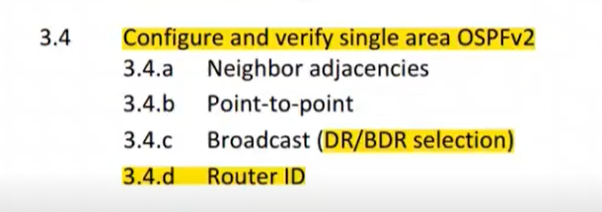

**OSPF Metric:**

OSPF uses a metric called cost, which is based on the bandwidth of an interface.

**Cost = Reference Bandwidth / Interface Bandwidth**

the reference bandwidth is a default value on Cisco routers which is a 100Mbit (108) interface.

Divide the reference bandwidth by the bandwidth of the interface and get the cost. The lower

the cost the better the path is. In route, that has lowest cumulative cost value between source

and destination will be selected for routing table. If two path is equal cost, OSPF will use both

paths and will load balance among them 50/50.

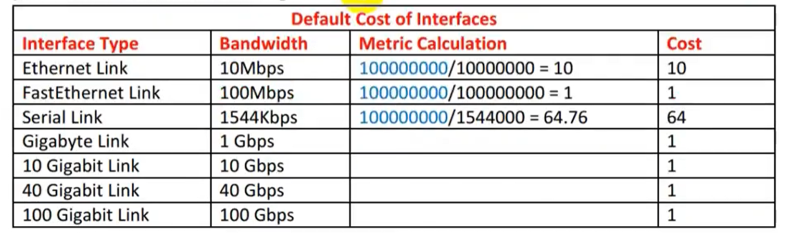

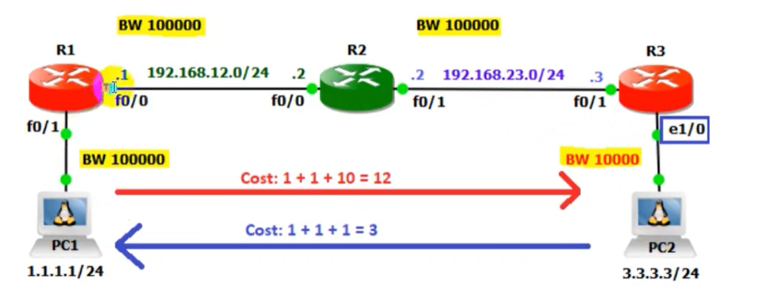

* From PCl to PC2 total OSPF cost is 12 because in the way one Ethernet link which is connected
* between R3 to PC2. Cost is counting from outgoing interfaces to reach destination. Therefore, from PCl to PC2 OSPF total cost is cost is 12 of RI, R2 and R3 outgoing interfaces.

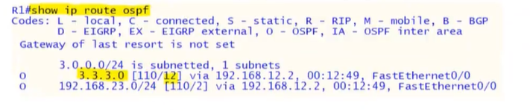

**Neighbor Configuration:**

To make two OSPF routers neighbors, simple enable OSPF on the connected interfaces. There

are two ways, by using the network command or by enabling the OSPF process on the interface

directly. OSPF Neighbor Requirements are mention below:

* The devices must be on the same subnet.
* Must not be passive on connected interface.
* The devices must be in the same area.
* The devices hello and dead intervals must match.
* Router IDs must be unique.
* The devices must have the same authentication configuration.

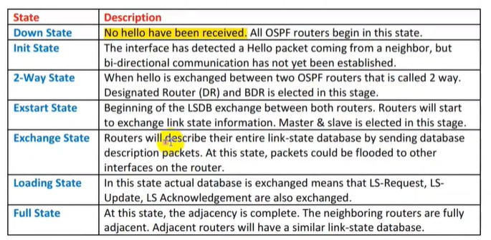

**OSPF Network Types:**

The network type defines how the neighbor relationship will be formed. Behavior of OSPF when

operating in these different network types — whether hellos are multicast or unicast, if DR/BDR

are elected, and so on. There are five different OSPF network types on a Cisco router point-to-

point, broadcast, non-broadcast, point-to-multipoint non-broadcast and point-to-multipoint.

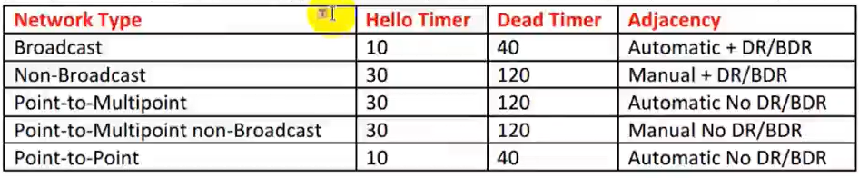

**Point-to-Point Network:**

This is the simplest form of the network types. Point-to-Point network types are intended to be

used between two directly connected routers. An example of a point-to-point link is a serial link

connecting just two routers using HDLC or PPP. With point-to-point links, OSPF does not select

a DR or BDR. In addition, hello packets are sent to the multicast address 224.0.0.5. The Point-to-

Point network type has a 10-second hello and 40-second dead timer. Discovers neighbors

dynamically.

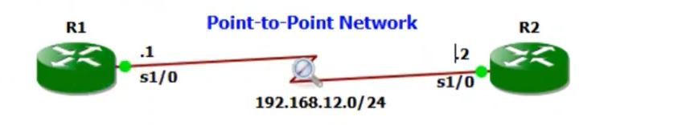

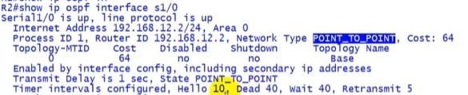

**Broadcast Networks:**

A network type that connects two or more OSPF routers over a broadcast media such as

Ethernet. The Broadcast network type requires that a link support Layer 2 Broadcast

capabilities. On broadcast networks, neighbors are dynamically discovered by the hellos that

sent to the multicast address of 224.0.0.5. In addition, DR and BDR are elected on these

networks. The Broadcast network type has a 10 second hello and 40 second dead timer.

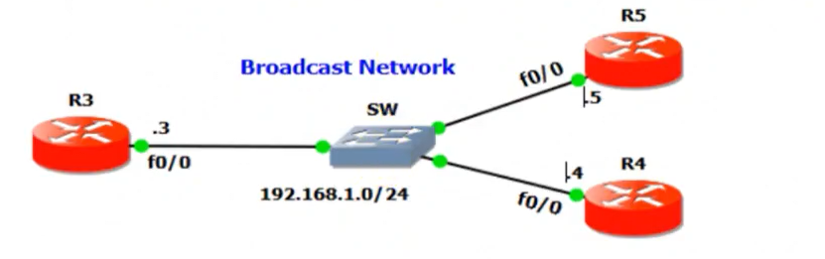

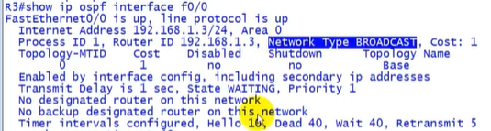

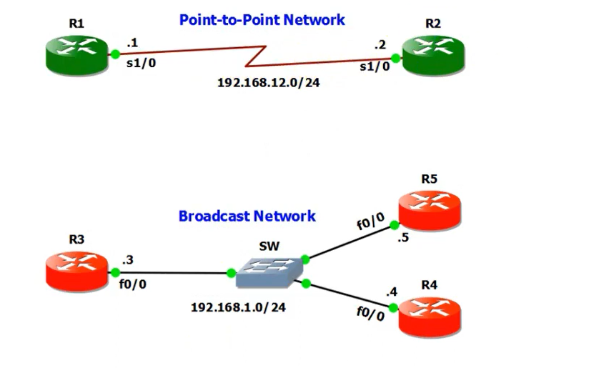

**Configure OSPF:**



Router 1:

R1(config)#interface f0/0

R1(config-if)#ip address 192.168.12.1 255.255.255.0

R1(config-if)#ecit

R1(config)#interface f0/1

R1(config-if)#ip address 1.1.1.100 255.255.255.0

R1(config-if)#exit

R1(config-if)#router ospf 1

R1(config-router)#network 192.168.12.1 0.0.0.255 (wild card) area 0

R1(config-router)#network 1.1.1.100 0.0.0.0 area 0

PC1:

Ip 1.1.1.1/24 with gateway 1.1.1.100

* That’s how first assign ips to the respective interfaces of the router and pcs then configure OSPF on the router including all the interfaces that should be participated in the protocol.

